

TRIBHUVAN UNIVERSITY

INSTITUTE OF SCIENCE AND TECHNOLOGY



HIMALAYA COLLEGE OF ENGINEERING

CHYASAL, LALITPUR

LAB REPORT NO. 10

**SUBMITTED BY: SUBMITTED TO:**

NAME: ABIN TIMILSINA DEPARTMENT OF Bsc. CSIT

ROLL NO.: 04 CHECKED BY:

**THEORY**

*Function:*

A piece or block of code that perform specific task is called function.

They are of two types

1. *Library function:* The functions which are already written compiled and placed into c library. Eg printf(), scanf(),etc
2. *User defined function:* The function which is defiend by programmer at the time of writing program. Eg:add()=Addition

*Syntax:*

<return_type><function_name>(<parameter/argument list>);

Void main()

{

<function_name>(arg1,arg2,……,argn);

<var_name>=<Function_name>(arg1,arg2,…..,argn);

}

<return_type><function_name><datatype>arg1,……,<datatype>argn)

{

//statements

// return statement

}

**Question 1**

**WAP to add, subtract, multiply and divide two integers using user defined function with return type.**

*Program:*

#include<stdio.h>

int add(int,int);

int sub(int,int);

int mul(int,int);

int div(int,int);

int main ()

{

int a,b,c,d,num1=10,num2=5;

a=add(num1,num2);

b=sub(num1,num2);

c=mul(num1,num2);

d=div(num1,num2);

printf("Add=%d sub=%d Mul=%d Div=%d",a,b,c,d);

return 0;

}

int add (int x,int y)

{

int sum;

sum=x+y;

return sum;

}

int sub (int x,int y)

{

int minus;

minus=x-y;

return minus;

}

int mul (int x,int y)

{

int M;

M=x*y;

return M;

}

int div (int x,int y)

{

int D;

D=x/y;

return D;

}

*Output:*

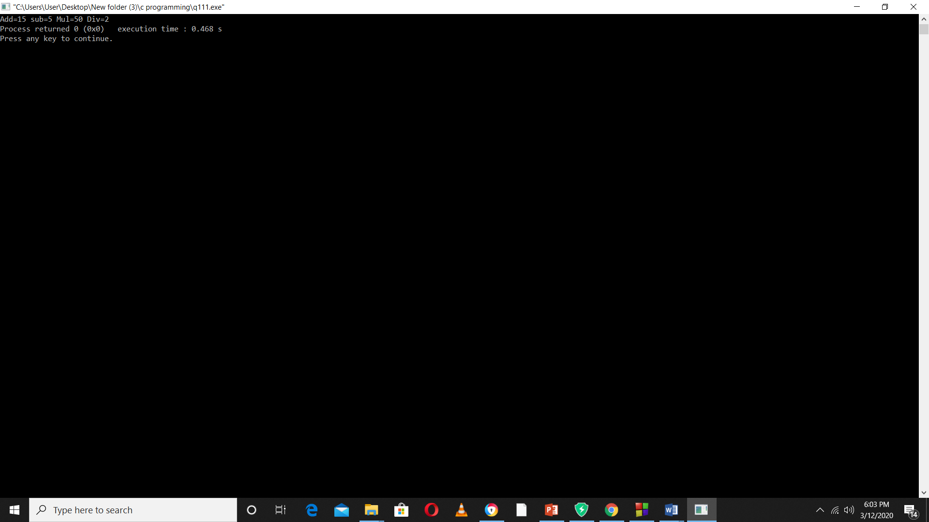

**Question 2**

WAP to find the sum of array elements using function with return type.

*Program:*

#include<stdio.h>

int sum (int a[],int);

int main ()

{

int a[5]={1,2,3,4,5};

int s;

s=sum(a,5);

printf("The sum of element of the arrayis %d",s);

return 0;

}

int sum(int a[],int n)

{

int i,s=0;

for(i=0;i<5;i++)

{

s=s+a[i];

}

return s;

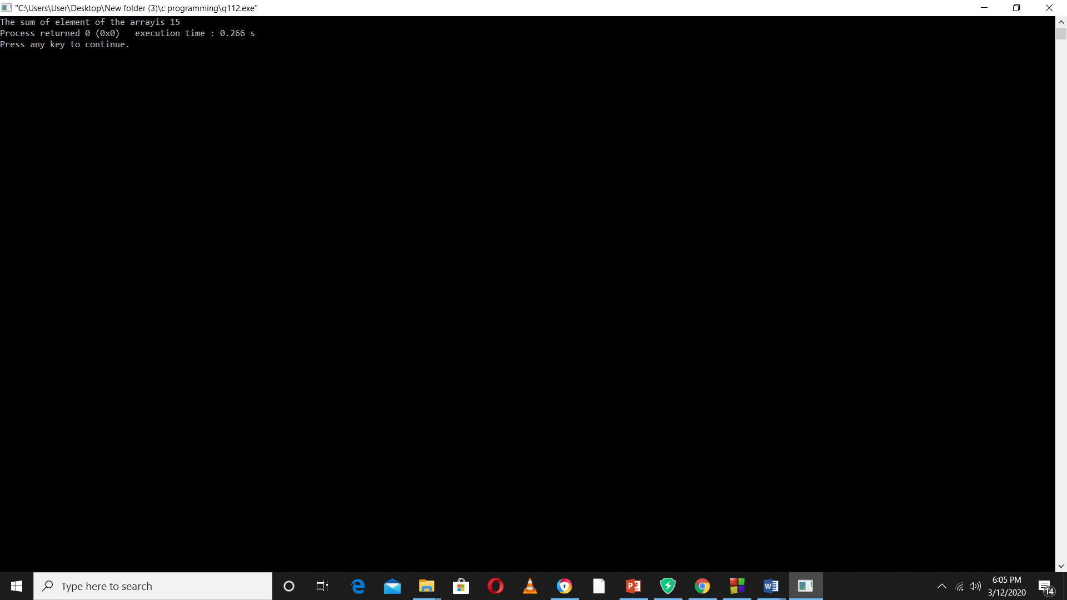}

*Output:*

**Question 3**

**WAP to swap two using call by value and call by reference methods of passing argument.**

*Program:*

#include<stdio.h>

int swap1(int,int);

int swap2(int*,int*);

int main ()

{

int a=7,b=9;

printf("Before the swap by call by value a=%d b=%d \n",a,b);

printf("Before the swap by call by reference a=%d b=%d \n",a,b);

swap1(a,b);

swap2(&a,&b);

return 0;

}

int swap1(int x,int y)

{

int t;

t=x;

x=y;

y=t;

printf("Swapped value from call by value is a=%d b=%d \n",x,y);

}

int swap2(int *x,int *y)

{

int t;

t=*x;

*x=*y;

*y=t;

printf("Swapped value from call by reference is a=%d b=%d \n",*x,*y);

}

*Output:*

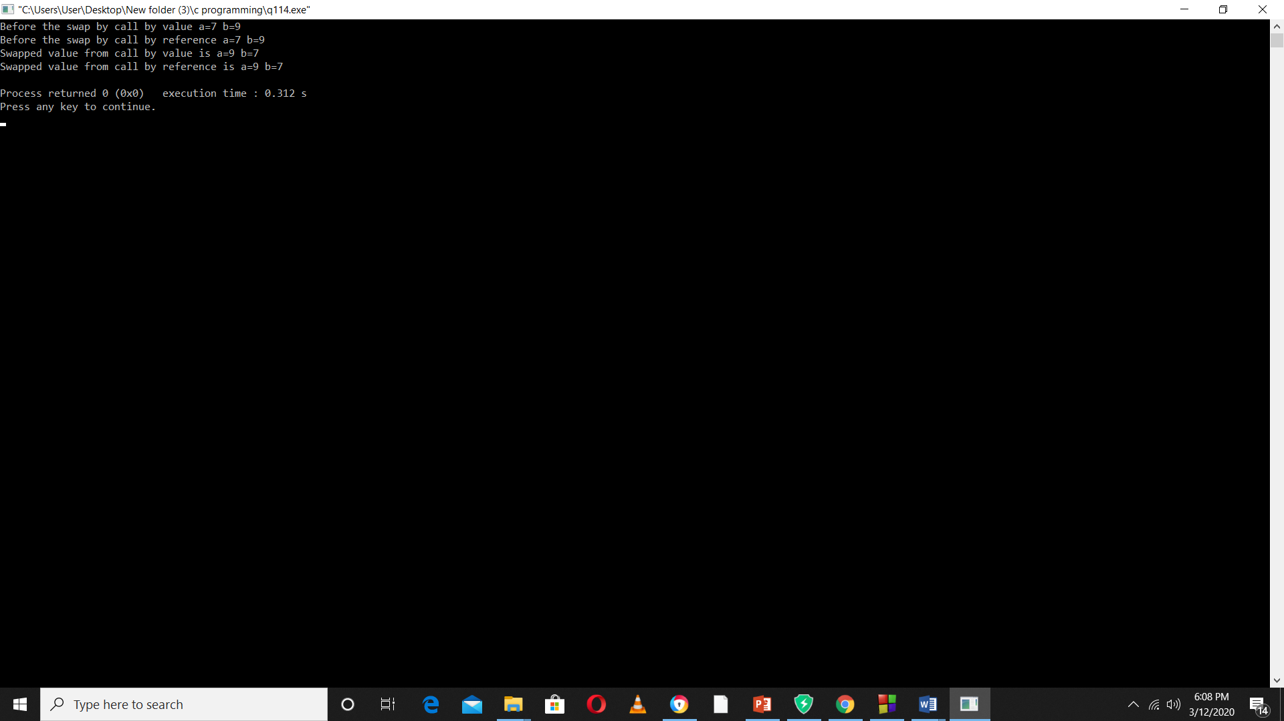

**Question 4**

**WAP to find the sum of digit of number using recursive function.**

Program

#include<stdio.h>

int sum(int);

int main()

{

int n,s;

printf("Enter any number=");

scanf("%d",&n);

s=sum(n);

printf("Sum of %d is %d",n,s);

return 0;

}

int sum(int x)

{

if (x==0)

return 0;

else

return (x%10+sum(x/10));

}

*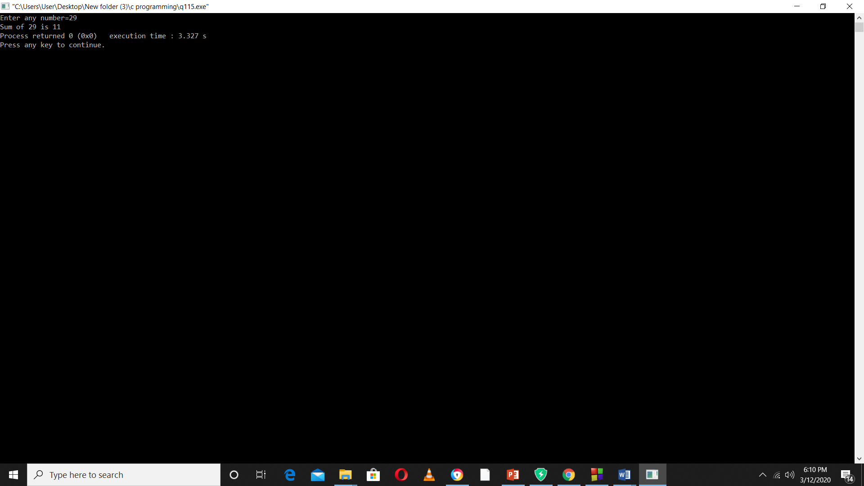Output:*

**Question 5**

**WAP to find the power of any number using recursive function.**

*Program:*

#include<stdio.h>

int power(int,int);

int main()

{

int a,n,p;

a=4;

n=2;

p=power(a,n);

printf("The value of a^n is %d",p);

return 0;

}

int power(int x,int y)

{

if (y==0)

return 1;

else

return (x*power(x,y-1));

}

*Output:*

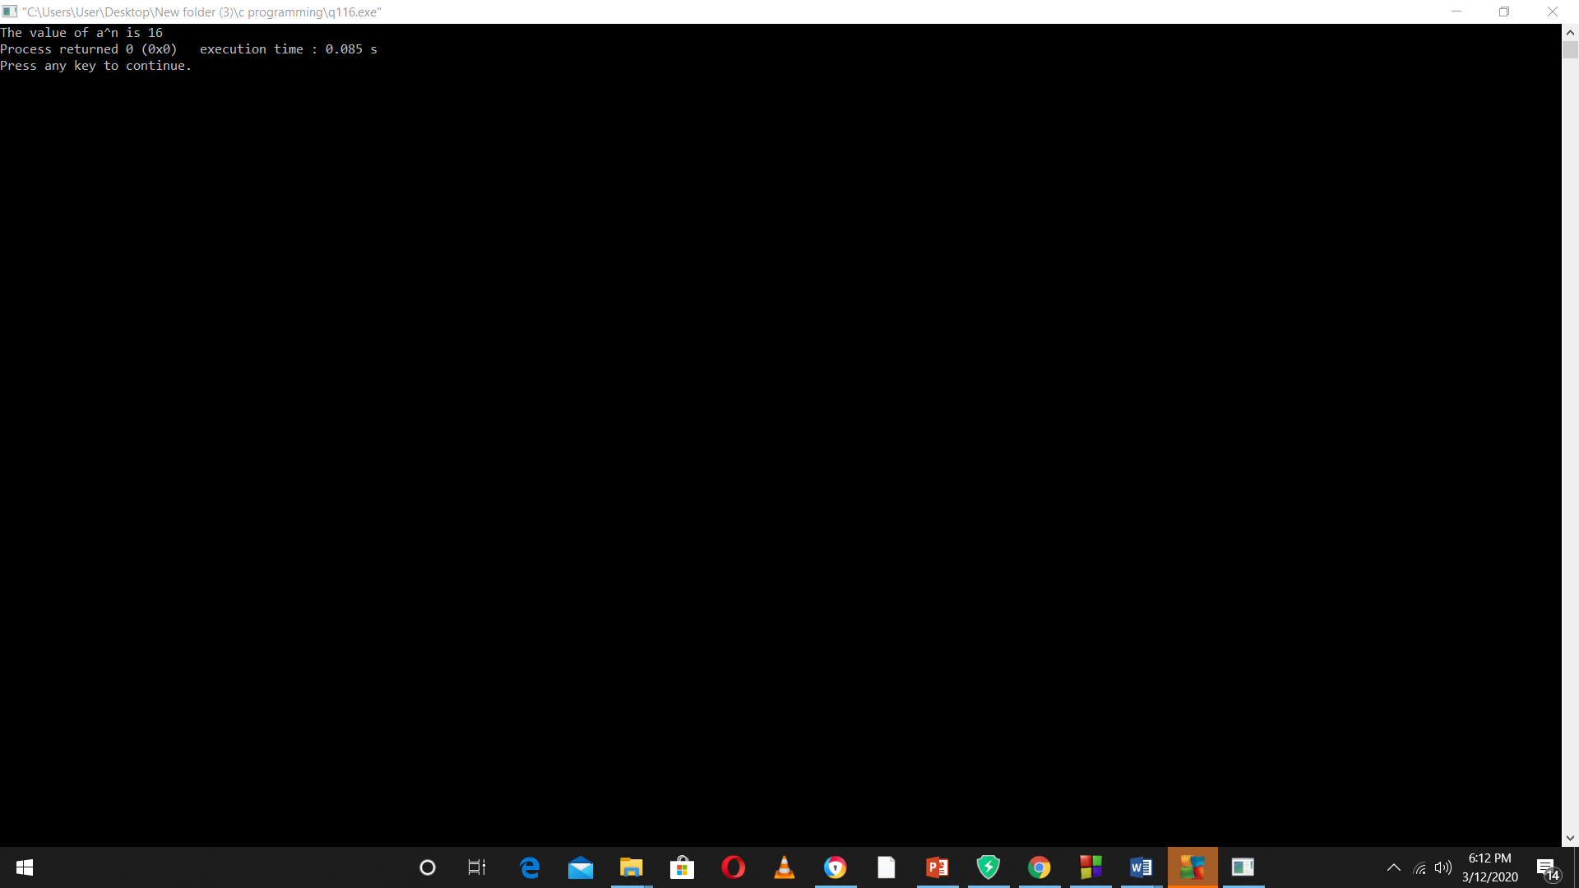

**Question 6**

**WAP to check whether the entered the entered string is palindrome or not.**

*Program:*

#include<stdio.h>

#include<string.h>

int main()

{

char str1[10];

char str2[10];

printf("Enter any string \t");

scanf("%s",str1);

strcpy(str2,str1);

strrev(str2);

if ((strcmp(str1,str2))==0)

printf("Palindrome");

else

printf("Not palindrome");

return 0;

}

*Output:*

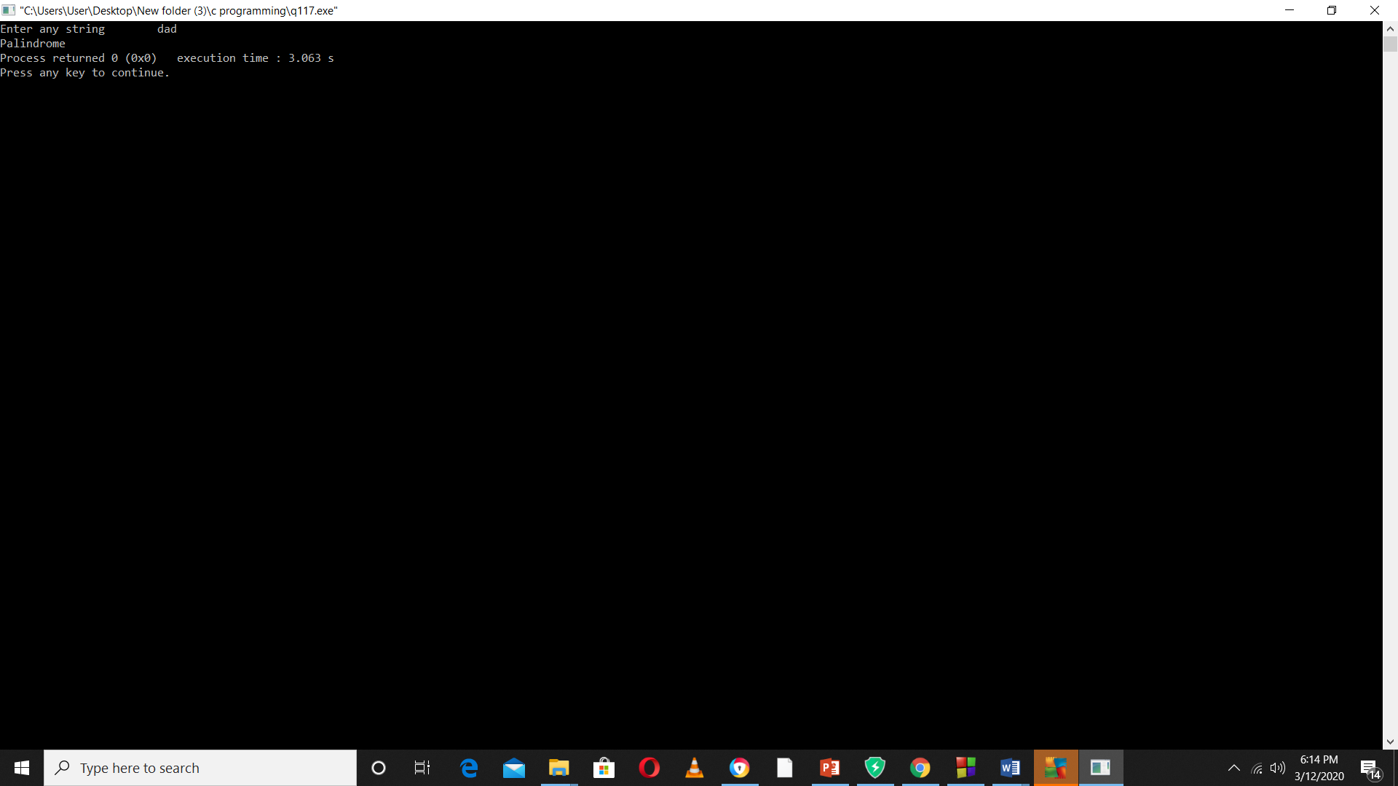

**Question 7**

**WAP to find reverse of a string using function.**

*Program:*

#include<stdio.h>

#include<string.h>

void rev(char str[],int);

int main()

{

char str[10];

printf("Enter string \n");

scanf("%s",str);

rev(str,10);

return 0;

}

void rev(char s1[],int n)

{

char s2[10];

int i=0,j,k;

while(s1[i]!='\0')

{

i++;

}

printf("%d \n",i);

k=0;

for(j=i-1;j>=0;j--)

{

s2[k]=s1[j];

k++;

}

printf("The reverse of the string is %s",s2);

}

*Output:*

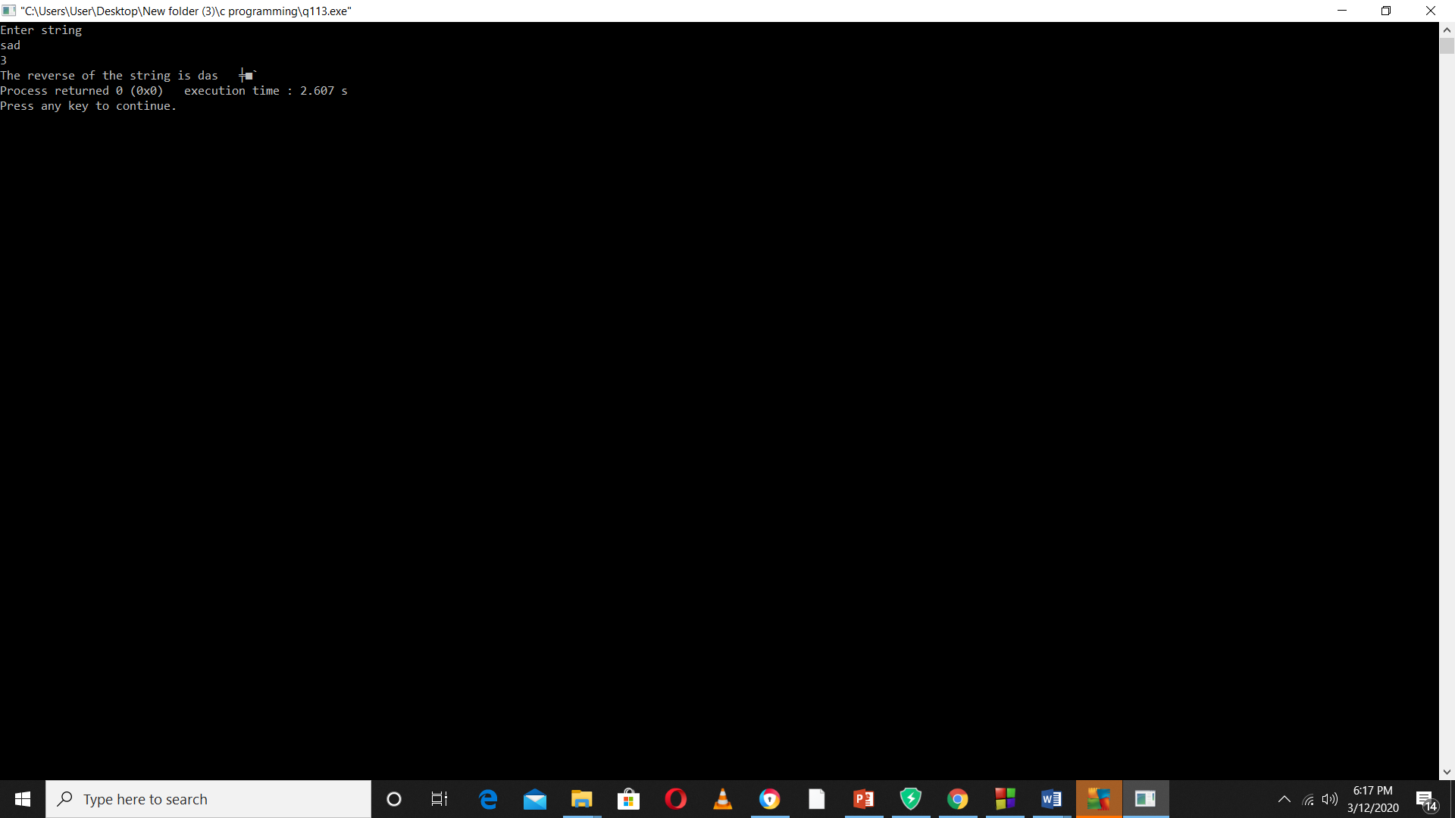

**Conclusion**

From this we can conclude or we learnt about **Function** and how it is used in array, function, string , structure which makes us easy for programming and we also learned about various types of function i.e. **Library function and User defined function.**